PlasmaGraph Poster Contents

# Logos

PUPR

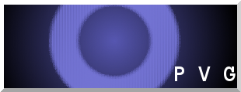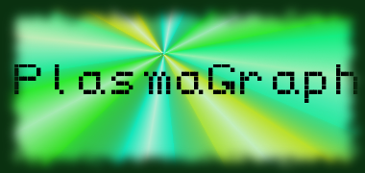

Polytechnic University of Puerto Rico

Electrical & Computer Engineering and Computer Science Department

Computer Science Senior Project

Spring 2014

# Project Information

PlasmaGraph

Created by Plasma Visualization Group

Client: Dr. Angel Gonzalez-Lizardo

# Abstract

The Polytechnic University of Puerto Rico runs a Plasma Laboratory wherein students perform various experiments under the supervision of Dr. Angel Gonzalez-Lizardo. The experiment data is obtained from the Laboratory’s Mirror and Cusp Plasma Machine. The resulting data is graphed using the Matlab software because the data is stored in a specially-formatted Matlab data file. However, the students find Matlab’s complex and cumbersome because they need to learn how to create a program that outputs the graph.

As a result, Dr. Angel Gonzalez-Lizardo requested to Plasma Visualization Group the development of a specialized graphing tool that substitutes Matlab. The client also requested that the learning time curve to use the new tool must be less than using Mathlab. In addition, the tool should eliminate the necessity to create a program that produces a graph.

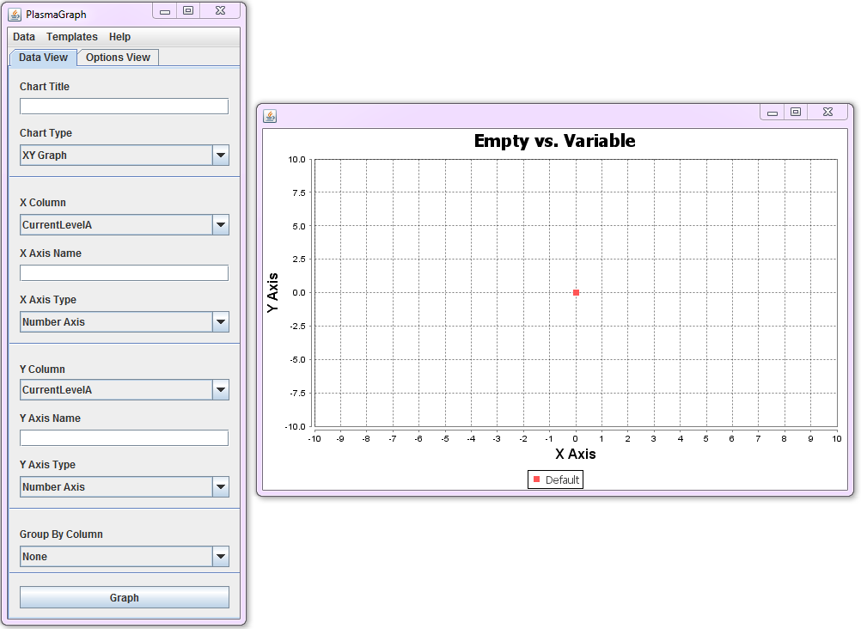Figure 1: Program Screenshot

# Feature Requirements

oración de introducción:

* Read Matlab Level-5 data files generated by the Laboratory’s Mirror and Cusp Plasma Machine
* Verify that the Matlab data files are correctly-formed and have valid data based in the following:
  + The file must be a Matlab-produced Level-5 binary file.
  + The file must contain one or more variables.
  + Each variable must contain a vector of length N and width 1.
  + All variables in the file must contain the same number of values.
  + Variables must be of types “double” or “cell”.
    - Double variables are used to store numerical values.
    - Cell variables are used to store text values in the form of Character arrays.
  + The file cannot be larger than 36,500 KB.
* Allow the user to select how the graph should be made (qué significa?)
* Produce graphs based on the data files and the user-selected options (cuáles son las opciones?)
* Save the graph as an image file (cuál es el formato?)
* Provide tools with which to add functionality in the future.

# Constraints?

# Timeline?

con las fases

# Budget?

oración de introducción(esto es estimado no el actual)

Table 1: PlasmaGraph Budget, Compressed

|  |  |
| --- | --- |
| **PlasmaGraph Budget** | |
| **Section** | **Cost** |
| Hardware | $1,955.99 |
| Software | $1,989.95 |
| Personnel and Locations | $74,000.00 |

# Graphical User Interface

The Graphical User Interface (GUI), as shown in Figure 1, provides the tools to manipulate graphs into the desired shape. The interface is separated into two sections:

* Data Settings: This window handles the options related to the visual components of the graph’s data, such as what columns will be used to graph, column axis names, graph title, and grouping column.
* Tool Settings: This window handles the options related to the tools available in PlasmaGraph, such as the Interpolation or Outlier Search capabilities.

Furthermore, the program allows the user to view the data contained in the file via the “View Data” option on the Menu Bar.

# Graphing

PlasmaGraph utilizes the tools provided by the Java-based “JFreeChart” library in order to create graphs. The program obtains the translated data file and provide a graph representative of what the user selected.

Figure 2: Sequence Diagram for the "Create Graph" Requirement

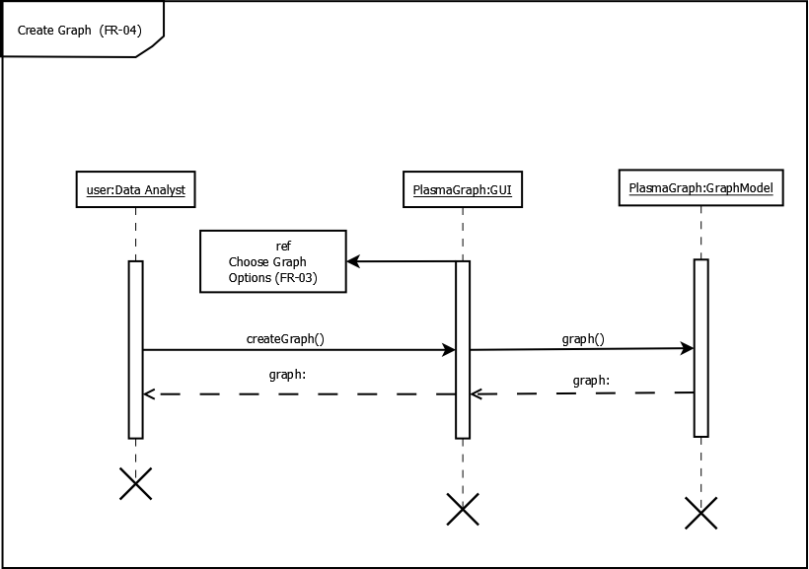

En el dibujo de secuencia, eliminen las X y las líneas de vida tienen que ser del mismo tamaño. El orden de ejecución de los servicios debe ser: createGraph(), luego se ejecuta "que operación?" ["selectGrapghSettings()"?] y finalmente graph(). Así que **ref** tiene que estar entre la flecha createGraph y graph

Figure 3: Example of a Graph generated by PlasmaGraph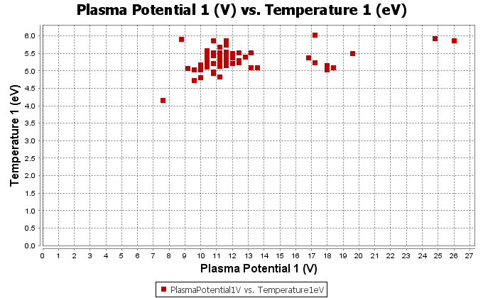

Añadan otros estilos de gráficas!!!

# Conclusion

After a comprehensive set of tests, PlasmaGraph proved to be a powerful graphing tool. Its testing encompasses all the requirements, as well as a variety of internal functions that PlasmaGraph uses in order to support its requirements. Manual tests (qué significa manual test?) were made using black box methods, while automated tests (qué significa automated test?) were made using white box methods. Performance [menos tiempo para aprender?] and Acceptance test? Therefore, we are confident this program will be a useful addition to the Plasma Laboratory’s data analysis tools.

# Future Feature Requirements

PlasmaGraph should include the following improvements:

* Create Bar Charts
* Graph in three dimensions utilizing a third column as an axis
* Allow to select the methods to Interpolate and Search for Outliers

# Design Team

Hagan una tabla que incluya nombre del grupo (Plasma Visualization Group), logo del grupo, sus nombres, id, programa y los roles

* + Gerardo A. Navas Morales (#69615) (Computer Science)
  + Daniel E. Quintini Greco (#73749) (Computer Science)